CS 207 Assignment 5

Group - 4

Rishi Sharma

Varun Singh  
Shreyansh Kulshreshtha

Vipul Sharma

1.

create table customer_quantity_copy( customerName varchar(255), QUANTITY int(11) );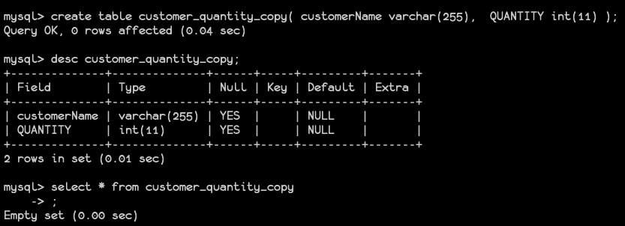

delimiter $$

create procedure copyCustomerQuantity ()

BEGIN

declare v_finished integer Default 0;

declare cName varchar(255) Default " ";

declare q integer Default 0;

declare quantityCursor cursor for

select customers.customerName, sum(orderdetails.quantityOrdered) from orders inner join orderdetails on orders.orderNumber = orderdetails.orderNumber inner join customers on customers.customerNumber = orders.customerNumber group by orders.customerNumber ;

declare continue handler for not found set v_finished = 1;

open quantityCursor;

getQuantity: loop

fetch quantityCursor into cName, q;

if v_finished = 1 then

leave getQuantity;

end if;

insert into customer_quantity_copy values(cName, q);

end loop getQuantity;

close quantityCursor;

END $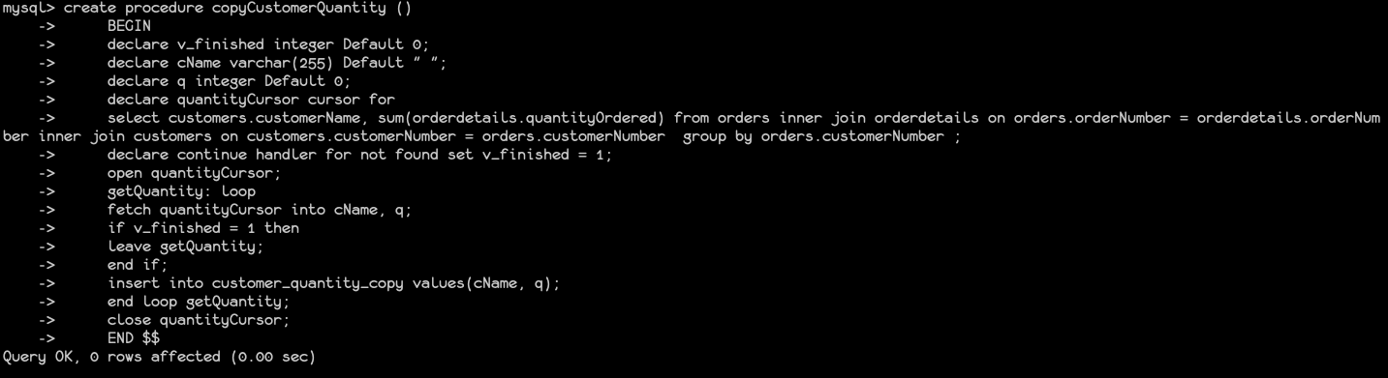

delimiter ;

call copyCustomerQuantity;

select * from customer_quantity_copy limit 10;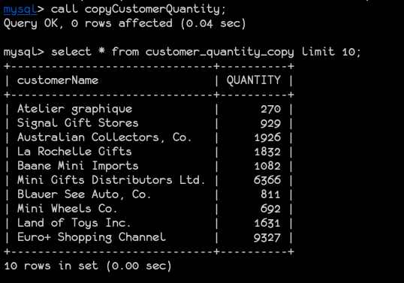

2.

create table employee_audit ( id int(11) primary key auto_increment, employeeNumber int(11) not null, lastname varchar(50) not null, changedat datetime, action varchar(50))$$

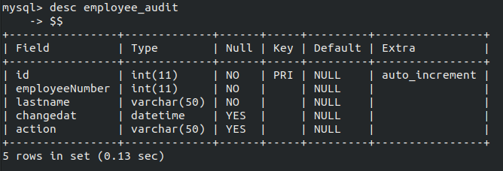

create trigger audit_before_update before update on employees for each row begin insert into employee_audit (employeeNumber, lastname, changedat, action) values (OLD.employeeNumber, OLD.lastname, CURRENT_TIMESTAMP, “update”); end$$

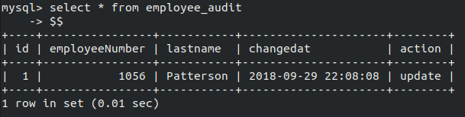

3.

create table customer_audit ( id int(11) primary key auto_increment, customerID int(11) not null, user_name varchar(50) not null, ContactName varchar(100) not null, changedat datetime, action varchar(50));

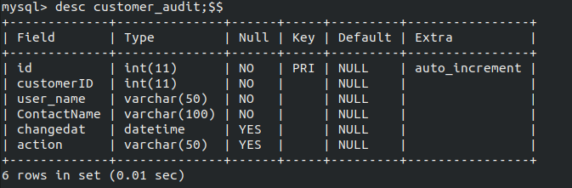

create trigger audit_after_delete after delete on Customers for each row begin insert into customer_audit (customerid, user_name, contactname, changedat, action) values (OLD.customerID, CURRENT_USER(), OLD.contactname, CURRENT_TIMESTAMP, "DELETE"); end$$

